Your name: Bryan

- Objective
- What question does this experiment answer / what hypothesis does it test?
- This experiment tests whether a simple OLS linear regression can predict LSOA-level GVA from the team's DAG features (SME business structure, economic resilience, employment, and controls) on the shared train_updated / test_updated split.
I build and evaluate three separate models, one per target:
- log_total_GVA_2023 - total economic output (2023)
- log_gva_per_worker_2023 - productivity (GVA per worker)
- log_GVA_2025_predicted - forward GVA estimate (2025)
Hypothesis: OLS should explain roughly 50–60% of variance (R²) for total GVA targets. Productivity (log_gva_per_worker_2023) should be harder to predict because it depends on workplace–resident geography (commuter hubs).

- Method
- Model name: Ordinary Least Squares (OLS) — sklearn.linear_model.LinearRegression (one independent model per target)
- Key hyperparameters / settings:
Data: train_updated.csv (900 rows), test_updated.csv (221 rows)
* Features (11): Urban_rura_Urban, LU_pct_micro_2025_msoa, LU_pct_large_2025_msoa, log_enterprises_per_1k_residents_2025, turnover_diversity_1-HHI_2025_msoa, LU_diversity_1-HHI_2025, share_enterprises_kibs_2025_msoa, emp_rate, full_time_share, log_Mid-2024 population, IMD_decile
Excluded from predictors: ID columns, is_swindon (used only in portability check)

Preprocessing: VIF check removed share_enterprises_foundational_2025_msoa → 11 final features
Settings: Default OLS — no regularisation, no hyperparameter tuning, no cross-validation
Robustness (optional): Swindon vs Others on test set; non-hub LSOAs (emp_rate ≤ 1)
- Evaluation approach: Fit on train, predict on held-out test. Report MAE, RMSE, MAPE, R² separately for each target.
- Please provide 1-2 papers related to your experiment
- Paper’s name: Goulet Coulombe, P. (2025). Ordinary Least Squares as an Attention Mechanism
- Paper’s Bib: @misc{coulombe2026ordinarysquaresattentionmechanism,
- title={Ordinary Least Squares as an Attention Mechanism},
- author={Philippe Goulet Coulombe},
- year={2026},
- eprint={2504.09663},
- archivePrefix={arXiv},
- primaryClass={cs.LG},
- url={https://arxiv.org/abs/2504.09663},
- }
4. Results — facts only, no interpretation
- Metric values (paste ):
Target | MAE | RMSE | MAPE (%) | R²
log_total_GVA_2023 | 0.4905 | 0.7357 | 14.43 | 0.5548
log_gva_per_worker_2023 | 0.4768 | 0.7112 | 4.23 | 0.1508
log_GVA_2025_predicted | 0.4993 | 0.7411 | 15.06 | 0.5684

- Key figures/charts (embed or link):
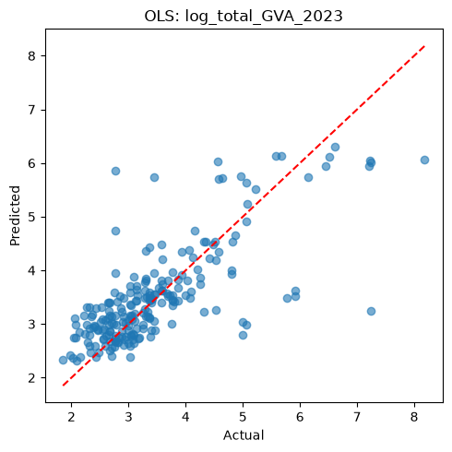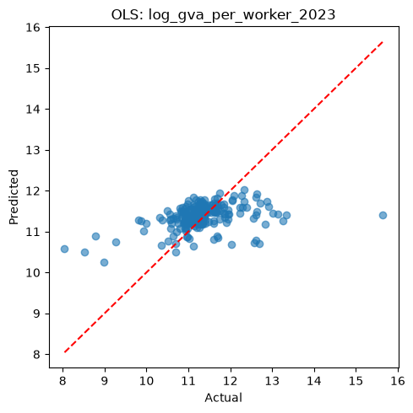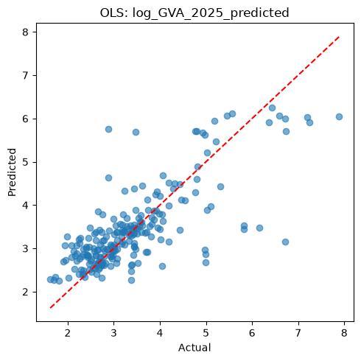
5. Discussion — your judgement
- What does this result show? OLS explains about 55% of variance for total GVA (log_total_GVA_2023, R² = 0.55) and forward GVA (log_GVA_2025_predicted, R² = 0.57), but only 15% for productivity (log_gva_per_worker_2023, R² = 0.15). SME structure, resilience, and employment features predict level of output better than GVA per worker. The scatter plots show total GVA points near the diagonal, while productivity predictions collapse toward the mean.
- How does it compare to the literature / the previous experiment?
Following Goulet Coulombe (2025), OLS is a valid prediction method,
uses train → predict on test, and it is interpretable (coefficients / weights), and combines features with coefficients (β)
our experiment :{11 features → GVA } works
I use OLS as an interpretable linear baseline that estimates each target as a weighted combination of SME structure, resilience, employment, and control variables, before comparing against LightGBM in Experiment 2.
- Anomalies / surprises:
- R² on Swindon test LSOAs (n=18) is higher than on other areas (e.g. 0.75 vs 0.53 for total GVA), suggesting the model generalises reasonably to Swindon despite training on mixed areas.
- Productivity paradox: log_gva_per_worker_2023 has the lowest R² (0.15) but the lowest MAPE (4.23%) — MAPE is low because values are on a tighter scale; R² is the better measure of explained variance here.
- High-GVA under-prediction: Scatter plots show several high-actual LSOAs predicted too low — likely commuter hubs or areas with workplace GVA not well captured by resident-based features.
• Live vs work check: Excluding commuter hubs (emp_rate > 1) drops R² from ~0.55 to ~0.41 on total GVA, confirming employment–GVA geography mismatch affects fit.

6. Reflection
- Planned approach vs. what was actually done:
Planned: Fit separate OLS baseline models for three GVA targets (log_total_GVA_2023, log_gva_per_worker_2023, log_GVA_2025_predicted) on the team’s train_updated / test_updated split, using 11 DAG features, and report MAE, RMSE, MAPE, and R² for each target.
- Actually done: Three LinearRegression models were trained and evaluated on the held-out test set. A full summary table (results_df) was produced, along with predicted vs actual scatter plots, a Swindon vs Others portability check (§9), and an optional non-hub robustness check excluding commuter hubs (emp_rate > 1,). One feature was removed after VIF screening, leaving 11 final predictors.
- Limitations / uncertainties:
LSOA GVA is ONS-estimated and workplace-based, not directly observed — so the target variable itself carries measurement uncertainty.
- Features come from mixed years (2023 GVA vs 2025 enterprise/resilience measures), which may weaken comparability.
- OLS assumes linear relationships; no regularisation or hyperparameter tuning was applied.
- emp_rate uses resident population while GVA is workplace-based, creating a live vs work geographic mismatch.
- Swindon portability results are based on only 18 test LSOAs, so those metrics may be unstable.
- is_swindon was used only for evaluation, not as a predictor
7. Next steps:
- Start Experiment 2 (LightGBM) on the same features, targets, and metrics.
- Compare LightGBM vs OLS — especially R² and RMSE on log_gva_per_worker_2023.
- Inspect feature importance from LightGBM to see which DAG variables matter most.

